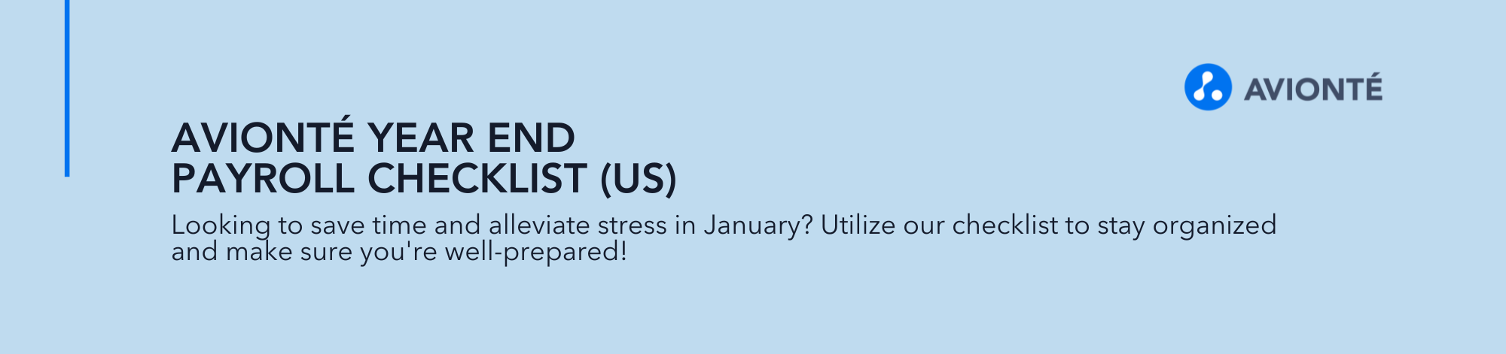
AUGUST, SepTEMBER, OCTOBER
☐ Confirm transaction type set up
☐ Add/review W2 box and label,
☐ Ensure transaction type is set up to include in ACA tracking
☐ Verify employee SSNs
☐ Gather consent for electronic delivery of W-2s, 1095-Cs and 1099s
☐ Create Adobe electronic consent form and distribute to employees not yet consented.
☐Confirm you are receiving the weekly Avionté BOLD Bulletin. Register online if you are not subscribed.
☐ Register for Year-End training webinar
☐ Review insurance plan(s) and benefit package(s) set up in the ACA Companion
☐ Add or update insurance plans as needed
☐ Add or update benefit packages as needed
☐ Review ACA Employers in the ACA Companion.
☐ Add any new suppliers to the ACA Companion.
☐ Review ALE group and dates.
☐ Review ACA Full Time status of employees using ACA Companion Census AQ
☐ Review insurance offers for ACA reporting using the ACA Companion Employee Offers AQ to view current year enrollments and declinations
☐Review ACA Full Time w/o Offer counter to determine if current ACA full time employees need an insurance offer.
☐ Need to enter insurance offers in the ACA Companion? Make a plan to enter insurance enrollments and declinations: manual entry or data import
☐Offering a self-insured plan? Learn about entering in dependents
☐ Update insurance offer dates in the ACA Companion as employees terminate
☐ If missing declinations in the ACA Companion, learn about the ACA Declination Export option so you are ready in January to use it.
☐Start and end assignments with accurate dates; correct start and end dates as needed
☐Review Greenshades properties in Admin Tools
☐Review company EIN and address in Admin Tools
☐Verify your company BNC as this will be needed for Greenshades tax filings.
☐ Need to determine the BNC? View IRS help

NOVEMBER & DECEMBER
☐ Plan for mailing your W-2s and 1095-Cs. In-house or outsource?
☐ Review BOLD Bulletin for Greenshades print and mail pricing.
☐ Learn more about the Greenshades print & mail process.
☐ Generate Feed & XML in Weekly Process
☐ Resolve any errors
☐ Identify tax filings you are required to file, (such as W-2s, 940, 1095-Cs, etc.) and document the filing deadlines.
☐ Review states you do business in for changes to minimum wage.
☐ Update minimum wage in Admin Tools
☐ Review states you do business in for changes to paid sick leave plans
☐ Determine if changes are needed for your company-specific PTO accrual plans
☐ Determine what changes are needed for new or updated employee benefits. Update enrollment forms.
☐ Review your Tax IDs for accuracy and ensure none are missing.
☐ Update/add Tax IDs in Admin Tools
☐ Collect your unemployment rate changes from states you do business in
☐Update unemployment tax rates in Admin Tools
☐ Work with your Worker’s Comp provider to determine if rates will be updated.
☐ Update WC rates in Admin Tools
☐ Prepare to distribute W-2s, 1095-Cs and/or 1099-NEC forms to your workers.
☐ Run Get W2 Details AQ to estimate number of W-2s
☐ If printing in house, order paper. Avionté preferred partner: Nelco Solutions
☐ Audit your payroll and W-2s. Create a list of employees in various states with varying tax and benefit scenarios (401K, insurance benefits, etc.)
☐ Identify employees that worked in one state, multiple states, had pre-tax deductions, were paid new transaction types, or pay types.
☐ Resolve any remaining ACA Companion sync errors
☐ Generate 1095-C forms and start to review.
☐ Review forms for accuracy by running the Get Employee 1095-C Info AQ and reviewing codes (reminder, the month of December will not be populated until you re-run in January)
☐ Determine final payroll date, check date, and communicate internally. Establish a firm deadline on when all payroll for the year will be finalized, including corrections.
☐ Process any final employee payments including bonuses, check corrections, etc.

JANUARY
☐Complete any final payroll adjustment or corrections
☐ Re-run Generate Feed & XML in Weekly Process after last payroll of the year and adjustments are complete
☐ Resolve any errors
☐ Audit W-2 data utilizing Get W2 Details AQ
☐Compare Form W-2 data to Taxes Summary AQ. Ensure totals match.
☐ Take the list of employees you created in December and audit those specific employee W-2s for accuracy.
☐ Review and verify all box totals on the W-2s.
☐ Ensure employer healthcare contributions are displayed on W-2
☐ If not capturing employer contribution in Avionté, use the Healthcare Contribution Import
☐ Regenerate 1095-C forms in the ACA Companion and do a final 1095-C review/audit.
☐ Verify 1095-C codes; use our code population guide to understand how the 1095-C codes are determined
☐ Use overrides as needed
☐ Print and mail forms to workers
☐ W-2s ☐1095-C ☐1099-NEC ☐Other
☐ Post forms to the employee portal
☐ W-2s ☐1095-C ☐1099-NEC ☐Other
☐ E-File required tax filings with the IRS and SSA via Greenshades
☐ W-2s ☐1095-C ☐1099-NEC ☐Other
☐ E-File annual tax filings such as 940 and state W-2s using Greenshades
☐ Complete standard quarterly filings for 941 and state unemployment, as with any prior quarter
☐ Review benefits to determine if new transaction types are needed.
☐ Create new transaction types as needed
☐ Create employee benefit plans where applicable
☐ Update employee payroll deductions for new or changed benefits
☐ Update employee/employer payroll contributions for new or changed benefits
☐ Mass update assignment pay rates for any applicable minimum wage changes.
☐ Update minimum wage changes in Admin Tools
☐ Review Accrual History AQ to verify accurate sick leave plan and PTO plan carryover
☐ Update Federal W-4 and state W-4s in your Adobe library using Avionté standard templates.
☐ Keep an eye on the BOLD Bulletin and AVI for notification of new templates.

AFTER January
☐Complete W-2Cs as necessary
☐Complete 1095-C corrects as necessary

Please note: This checklist is intended for clients utilizing AviontéBOLD, and that also utilize the ACA Companion and Greenshades. If using AviontéCLASSIC, not all items will be applicable.

